PREPARE

~$ sudo apt install git bc bison flex libssl-dev make ( thu vien git).

~$ git clone --depth=1 -b rpi-5.4.y https://github.com/raspberrypi/linux (kernel source).

~$ sudo apt install crossbuild-essential-armhf (tool chain ).

~$ sudo apt install libncurses5-dev

CONFIG KERNEL

cd linux/

~/linux$ KERNEL=kernel7l (raspberry pi 4) (KERNEL=kernel7 (raspberry pi 2,3,3+)

~/linux$ make ARCH=arm CROSS_COMPILE=arm-linux-gnueabihf- bcm2711_defconfig

~/linux$ make ARCH=arm CROSS_COMPILE=arm-linux-gnueabihf- menuconfig

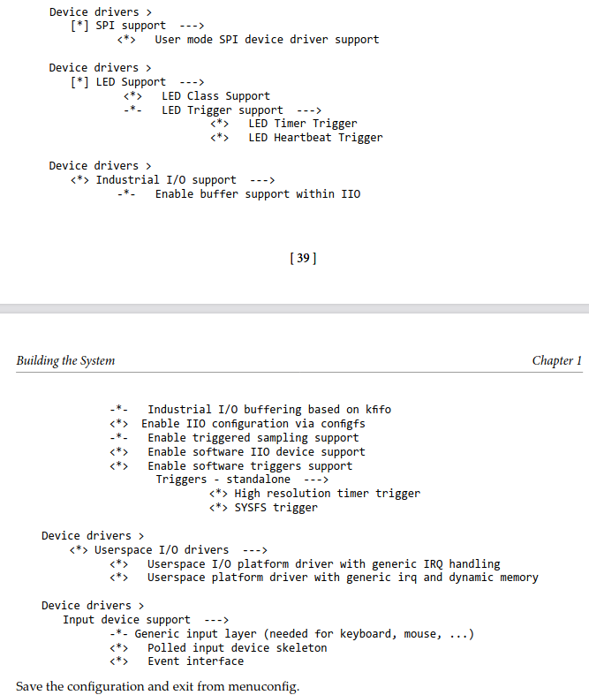

BUILD KERNEL

~/linux$ make -j6 ARCH=arm CROSS_COMPILE=arm-linux-gnueabihf- zImage modules dtbs

COPY TO SD CARD

~$ lsblk

~$ mkdir ~/mnt

~$ mkdir ~/mnt/fat32

~$ mkdir ~/mnt/ext4

~$ sudo mount /dev/sdb1 ~/mnt/fat32/ (thay doi tuy may)
~$ sudo mount /dev/sdb2 ~/mnt/ext4/ (thay doi tuy may)

~/linux$ sudo env PATH=$PATH make ARCH=arm CROSS_COMPILE=arm-linux-gnueabihf INSTALL_MOD_PATH=~/mnt/ext4 modules_install

~/linux$ sudo cp ~/mnt/fat32/kernel7l.img ~/mnt/fat32/kernel7l-backup.img

~/linux$ sudo cp arch/arm/boot/zImage ~/mnt/fat32/kernel7l.img

~/linux$ sudo cp arch/arm/boot/dts/*.dtb ~/mnt/fat32/

~/linux$ sudo cp arch/arm/boot/dts/overlays/*.dtb* ~/mnt/fat32/overlays/

~linux$ sudo cp arch/arm/boot/dts/overlays/README ~/mnt/fat32/overlays/

~$ sudo umount ~/mnt/fat32
~$ sudo umount ~/mnt/ext4

